Emp_dataset

- Imported the dataset, and performed the EDA
- Plotted histogram plot for S.h and found that it is slightly right skewed
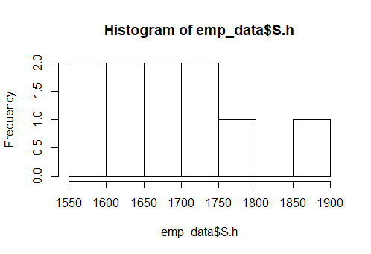
- Also plotted several other plots like boxplot and scattered plot
- Then plotted between input and output to find out their correlation
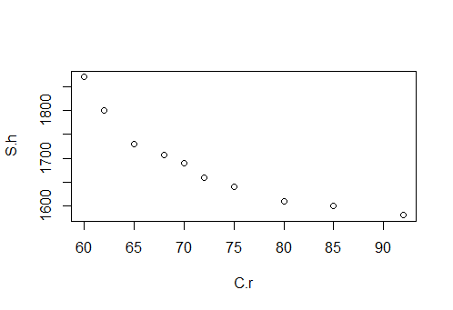
- Extremely high negative correlation exits between input and output.
- Then formed several models with or without transformations and found the model.2 was the best one
- model.1- S.h=2285.365-8.186 (C.r), r=-0.9117216, R^2=0.8312, rmse= 35.89264
- for 98% confidence
- lwr =2007.56145 -11.96333 (C.r)
- upr =2563.169141-4.408831(C.r)

- model.2- S.h=4366.44-625.60(log(C.r)), r= -0.9346361, R^2=0.8735, rmse=31.06952(best model)

